Shoot The Lobster – Dusseldorf
Worringer Strasse 103 @ Benzulli
40210 Dusseldorf, Germany
contact@shootthelobster.com
212 560-0670
www.shootthelobster.com

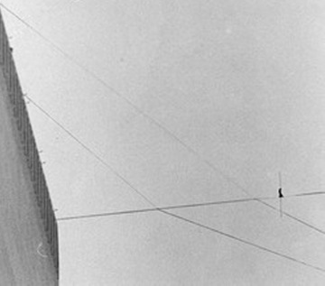

Wire
Katherine Bauer
Johannes Döring
Ryan Foerster
Agnes Lux

Reception: January 11, 2013, 7 pm – 12 am

FOR IMMEDIATE RELEASE

Hours: January 12, 2 – 6 pm and January 13, 2 – 6 pm, and by appointment.

Benzulli
Worringer Strasse 103 (Backyard) 40210 Dusseldorf, Germany
www.benzulli.com
www.facebook.com/benzulli
http://shootthelobster.com

Wire denominates an action as a verb — to wire — as well as a noun for it's facilitator — the wire — always mentioning the process of its onset as well as the existence of a second entity - its tying and conducting qualities.

The work included in this show follows certain guidelines in its making. Randomized chance and determined handling have a reciprocal relationship filtering outside sources through the specific machines and processes of each artist’s hand.

Katherine Bauer films landscapes and architectures to create abstracted images generated by the subject and the technical features of the 16mm film camera. The result is an alternate option of reading histories of creation.

Johannes Döring's work is developed by preoccupation with the contemporary use of the imagination of virtuality as a generated reality. On the one hand photography is a document, its traditional function making one aware of a moment gone. On the other hand it is the transition of the representation. The image may be the starting point but the result is a sculpture whose imprint is an image.

Ryan Foerster utilizes the randomness of nature to complete his artwork. Distinct gestures reacting to and acting with nature within the realm of photography contradict the reproducibility of photographic images per se, and the insistence on a hand-made object.

Agnes Lux uses postcards made by the USPS for the production of her abstract drawings. Blending the records of the process of making and the route of sending into simultaneous readable filmstrips on grids. Postcards are objects used as a foundry of abstraction as the cards are not carriers of direct content - rather emails would be send to answer urgent questions - but they are an ornamentation of communication as strategy.

For further information please contact: contact@shootthelobster.com or 212 560-0670

